Scrum Master for Automotive.
1. Introduction to Agile in Automotive Projects
What is Agile?
Agile is an iterative and incremental development approach that focuses on:
- Customer collaboration
- Continuous improvement
- Early and frequent delivery of working software
Why Agile in Automotive Software?
Automotive software development involves:
- Embedded systems (ECUs, ADAS, infotainment)
- Frequent requirement changes (regulations, safety, customer features)
- Integration with hardware
Agile helps by:
- Delivering software in small increments
- Detecting integration issues early
- Improving cross-functional collaboration (software, hardware, testing)

2. Scrum Framework Overview
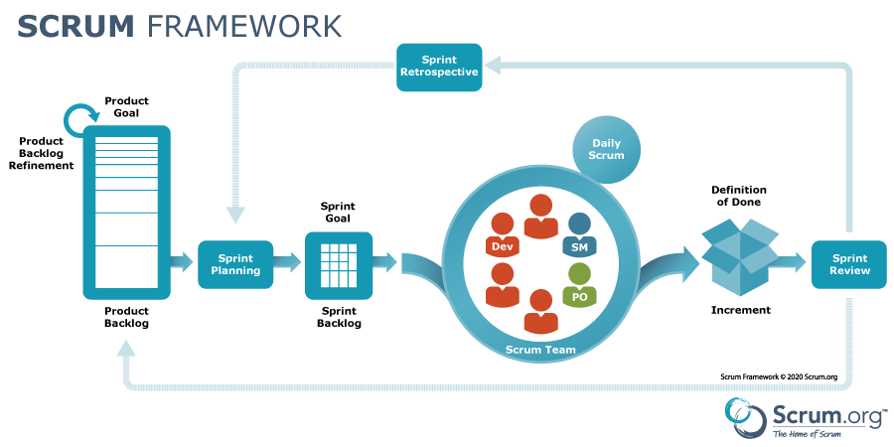
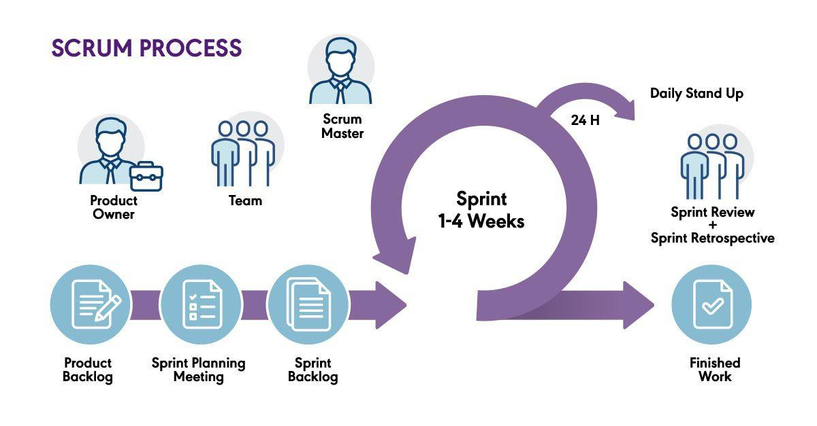
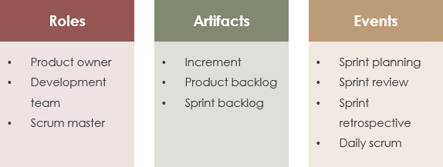
What is Scrum?
Scrum is an Agile framework used to manage complex software projects using time-boxed iterations called Sprints.
Core Elements of Scrum
Scrum consists of:
- Roles
- Events
- Artifacts

3. Scrum Roles (Automotive Context)
1. Scrum Master
Primary Responsibilities:
- Facilitates Scrum events
- Removes impediments
- Coaches team on Agile principles
- Ensures Scrum is followed correctly
Automotive Example:
- Resolving dependency issues between ECU software and hardware teams
- Addressing delays due to CAN communication issues

2. Product Owner
Responsibilities:
- Owns the Product Backlog
- Defines priorities
- Represents customer and regulatory needs (ISO, ASPICE)
Automotive Example:
- Prioritizing ADAS safety features over infotainment updates

3. Development Team
Characteristics:
- Cross-functional (developers, testers, integration engineers)
- Self-organizing
- Typically 5–9 members
Automotive Example:
- Embedded C developers
- AUTOSAR engineers
- Validation and HIL testers

4. Scrum Artifacts
Product Backlog
- Ordered list of features, bug fixes, technical tasks
- Owned by Product Owner
Automotive Example Items:
- Implement adaptive cruise control logic
- Fix CAN message timing issue
- Integrate new sensor driver

Sprint Backlog
- Subset of Product Backlog selected for a Sprint
- Includes tasks and acceptance criteria

Increment
- Working, tested software at the end of each Sprint
- Must meet Definition of Done
Automotive Definition of Done Example:
- Code reviewed
- Unit tested
- MISRA compliant
- Integrated with ECU build

5. Scrum Events (Ceremonies)
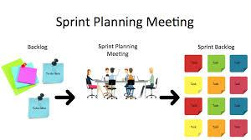
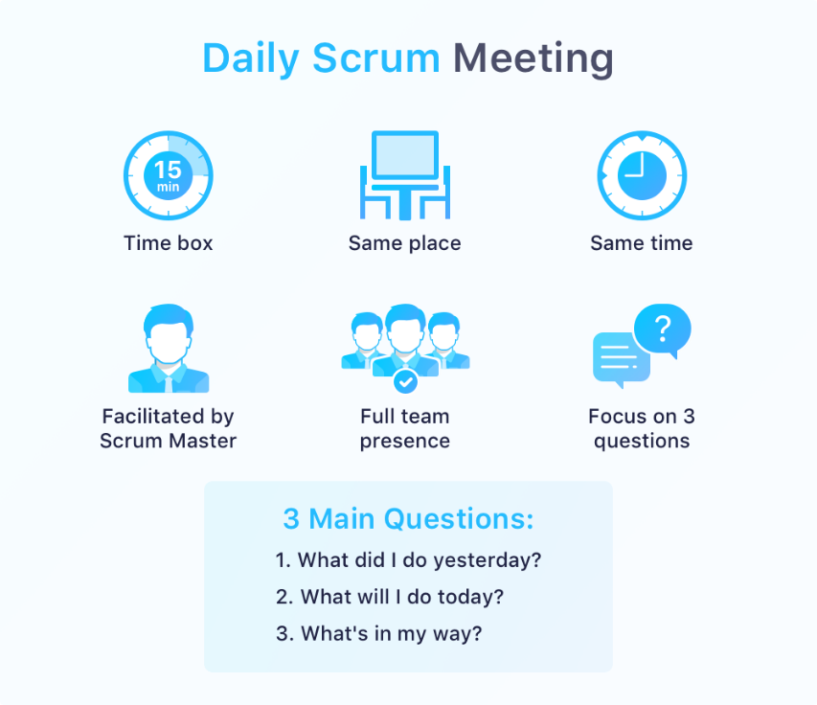
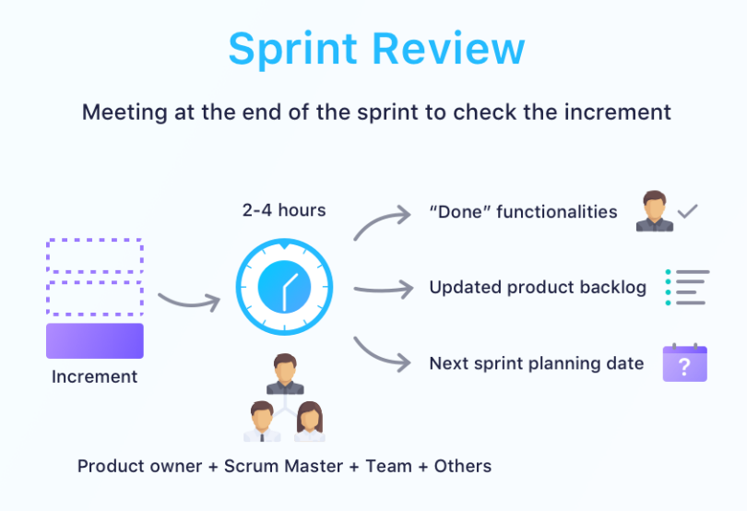
4
Sprint
- Fixed duration (usually 2–3 weeks)
- Goal: deliver a usable software increment

Sprint Planning
Purpose:
- Define Sprint Goal
- Select backlog items
- Break work into tasks

Automotive Focus:
- Hardware availability
- Integration dependencies
- Safety constraints

Daily Scrum (Stand-up)
3 Key Questions:
- What did I do yesterday?
- What will I do today?
- Any blockers?
Scrum Master Role:
- Identify blockers (tool issues, hardware delays)
- Follow up after the meeting

Sprint Review
- Demonstrate working software
- Gather feedback from stakeholders
Automotive Example:
- Demo lane-keeping assist feature on simulation or test bench

Sprint Retrospective
- Inspect and improve team processes
- Identify what went well and what needs improvement

6. Sprint Planning & Execution in Automotive Projects
Sprint Planning Steps
- Review Product Backlog
- Define Sprint Goal
- Estimate effort (story points)
- Identify dependencies (hardware, suppliers)
- Commit to Sprint Backlog

Execution Best Practices
- Continuous integration with ECU builds
- Early testing using simulators or HIL
- Frequent communication with hardware teams

7. Monitoring Progress & Addressing Challenges
Common Automotive Agile Challenges
- Hardware dependency delays
- Supplier integration issues
- Safety and compliance constraints
- Long testing cycles

Scrum Master Techniques
- Use impediment board
- Conduct dependency mapping
- Facilitate cross-team synchronization
- Encourage automation (CI/CD, testing)

Agile Metrics
- Sprint Burndown Chart
- Velocity
- Defect leakage
- Sprint predictability

8. Scrum Management Tools – Jira
Jira is widely used for Scrum project management.
Key Jira Features for Scrum Masters
- Product & Sprint Backlogs
- Scrum boards
- Burndown charts
- Velocity reports
- Issue tracking

Jira Workflow for Automotive Projects
- Create Epics (ADAS, Infotainment, Body Control)
- Break into User Stories
- Assign Story Points
- Plan Sprint
- Track progress daily
- Review reports after Sprint

Jira Issue Types (Example)
- Epic: Autonomous Parking
- Story: Implement ultrasonic sensor logic
- Task: Write sensor interface code
- Bug: Fix CAN timeout issue

9. Role of Scrum Master in Automotive Success
Key Skills Required
- Strong Agile & Scrum knowledge
- Embedded systems understanding
- Communication & facilitation skills
- Conflict resolution
- Tool proficiency (Jira, Confluence)

Scrum Master Value Addition
- Faster delivery of automotive features
- Reduced integration risks
- Improved team morale
- Higher product quality

10. Summary Cheat Sheet
- Scrum is ideal for complex automotive software
- Scrum Master is a servant leader
- Focus on people, process, and delivery
- Jira helps visualize and manage work
- Continuous improvement is key

